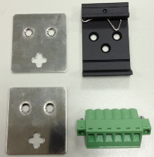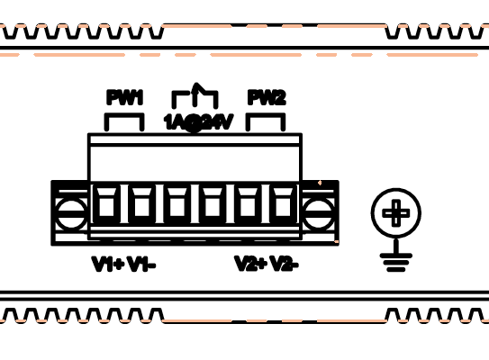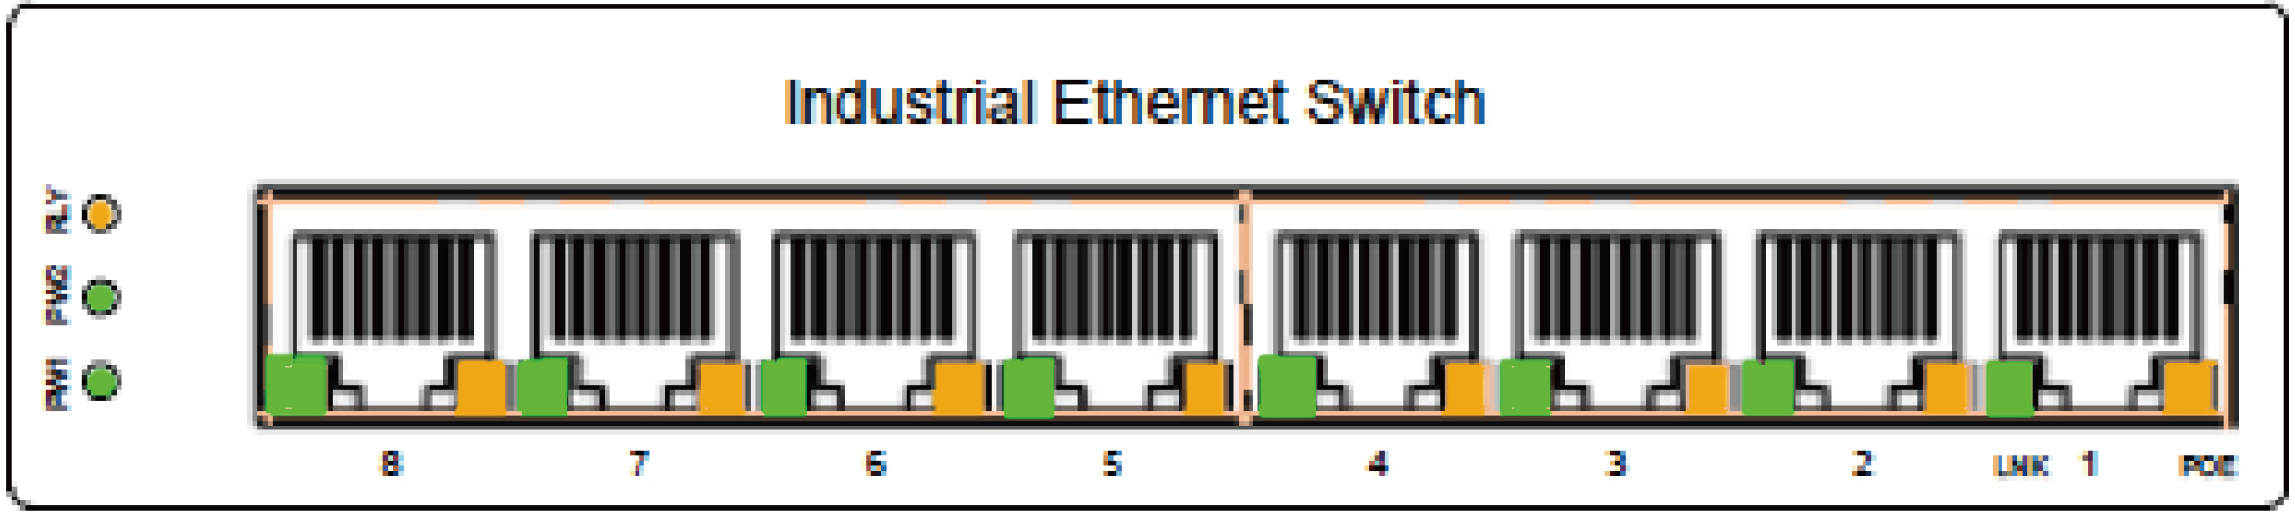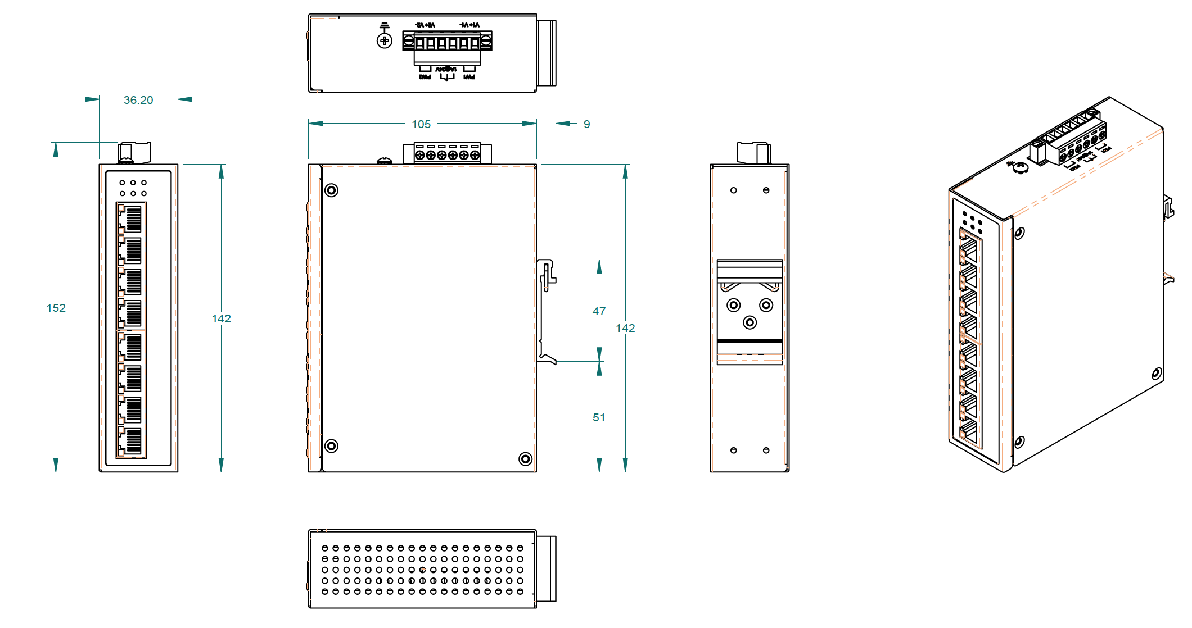

User Manual

Industrial Gigabit 8 port POE Switch, with 4 x 10/100/1000M PSE IEEE802.3af/at, 4 x 10/100/1000M TX, input power 48-56 VDC, -20°C to 70°C ( T model -40°C to 75°C)

FCC MARKING

This Equipment has been tested and found to comply with the limits for a Class A digital device, pursuant to part 15 of the FCC Rules. These limits are designed to provide reasonable protection against harmful interference when the equipment is operated in a commercial environment. This equipment generates, uses, and can radiate radio frequency energy and, if not installed and used in accordance with the instruction manual, may cause harmful interference to radio communications.

Operation of this equipment in a residential area is likely to cause harmful interference in which case the user will be required to correct the interference at his own expense.

This device complies with Part 15 of the FCC Rules. Operation is subject to the following two conditions: (1) this device may not cause harmful interference, and (2) this device must accept any interference received; including interference that may cause undesired operation.

CE MARKING

This equipment complies with the requirements relating to electromagnetic compatibility, EN 55022 class A for ITE, the essential protection requirement of Council Directive 2004/108/EC on the approximation of the laws of the Member States relating to electromagnetic compatibility.

Company has an on-going policy of upgrading its products and it may be possible that information in this document is not up-to-date. Please check with your local distributors for the latest information. No part of this document can be copied or reproduced in any form without written consent from the company.

Trademarks:

All trade names and trademarks are the properties of their respective companies.

Copyright © 2013, All Rights Reserved.

This industrial Gigabit 8 port POE switch is equipped with 4 x Giga PSE port, each port can deliver 30W POE power. It comes with a 6 pin terminal block. It can be connected with 48-56VDC power source. Always Make sure to use 56VDC for IEEE802.3at or 30W power connection.

WARNING – any exceeded input voltage will not make this unit function and may damage this unit.

To make power connection – Follow the printed polarity for V1+, V1-, V2+, V2-, and ground. Connect positive wire to V+ , connect negative wire to V-, also connect neutral wire to the ground screw as shown .

Relay -- You may use 24V@1A relay connection to your external device for special purpose. When 2 powers are connected, the relay is in OPEN mode. When any power source fails, the relay change to SHORT status.

Power connecting procedure:

STEP 1 – Pull out 6 pin terminal block.

STEP 2 – Connect wire to V1+, V1-, or V2+, V2-, and Ground the neutral wire to the ground screw.

STEP 3– Plug back 6 pin terminal block to its place.

**WARNING –**

**Always ground the power source to maintain a clean power input. Due to too many cheap made power supplies, it creates too much noise, and it will cause the power input fluctuates when connect to this unit. To avoid this, always ground the power source to gain a clean power input.**

Din Rail Bracket x 1

Wall mount bracket x 2

6 pin Terminal Block x1

This unit can be installed by din-rail mounted or wall-mounted. Din-rail brackets and wall-mounted bracket are included.

Installation package

Power connection

Amber LED ---

ON = POE detected

OFF = POE not detected

Flash = POE detecting.

**DATA**

**POE**

Relay LED Amber

ON one power is connected

OFF two powers are connected

Green LED ---

ON =Link

Flash = TX/RX.

PW2

ON -- when V2+, V2- is connected

PW1

ON -- when V1+, V1- is connected

LED indicator

Specification:

|  |  |
| --- | --- |
| **IEEE Standard** | IEEE 802.3 10Base-T Ethernet IEEE 802.3u 100Base-TX Fast Ethernet IEEE 802.3ab 1000Base-T Gigabit Ethernet IEEE 802.3z 1000Base-X Gigabit Ethernet IEEE802.3x Flow Control and Back Pressure,  IEEE802.3af for POE  IEEE802.3at for POE+ |
|
| **Switch Architecture** | Back-plane (Switching Fabric): 16Gbps |
| **Data Processing** | Store and Forward |
| **Flow Control:** | IEEE 802.3x Flow Control and Back Pressure |
| **Jumbo Frame** | 9KB |
| **MAC address Table Size** | 8K |
| **Packet Buffer Size** | 1M |
| **Network Connector :** | 4xRJ-45 10/100/1000BaseT(X) auto negotiation,  4 Giga POE+ 802.3at/af PSE port Auto MDI/MDI-X function, Full/Half duplex |
| **Network Cable** | UTP/STP above Cat.5e Cable |
| EIA/TIA-568 10-ohm (100m) |
|  |
| **Protocol** | CSMA/CD |
| **LED** | PW1(Power 1) Green,  PW2(Power 2) Green,  SW(relay) Amber, |
| TX/RJ-45 port:  LNK (Link/Active) Green,  Amber: POE Detected |
|  |
| **Housing** | Heavy Metal Housing |
| **Reserve polarity protection** | Present |
| **Overload current protection** | Present |
| **Power Supply** | Redundant Dual DC 48V-56V Power Input  POE input 48-56VDC |
| **Power Consumption** | 5.76W@48 VDC full load, Without POE |

|  |  |
| --- | --- |
| **Alarm Relay Contact** | Relay outputs with current carrying capacity of 1 A @24VDC,  Relay in short circuit mode when 2 powers are connected. in open circuit mode when only one power supply is connected |
| **POE power** | POE power per port 30watts. Maximum 126Watts  Maximum total power 126Watts with 56VDC input, Supports IEEE802.3af/at |
| **Removable Terminal Block** | Provide 2 Redundant power , Alarm relay contact ,6 Pin  Wire range: 0.34mm^2 to 2.5mm^2  Solid wire (AWG):12-24/14-22  Stranded wire(AWG): 12-24/14-22  Torque:5lb-In/0.5Nm/0.56Nm  Wire Strip length: 7-8mm |
| **Operating Temperature** | -20℃~70℃ fully tested. ( T model -40°C to 75°C also available) |
| **Operating Humidity** | 5% to 95% (Non-condensing) |
| **Storage Temperature** | -40℃~85℃ |
| **MTBF (mean time between failure)** | 510,304 hrs ( MIL-HDBK-217F) at 25°C |
| **Housing** | Rugged Metal ,IP30 Protection |
| **Case Dimension (L x W x D)** | 142mmx36.2mmx105mm (LxWxD) |
| **Installation mounting** | DIN Rail mounting and Wall Mounting |
| **Certifications:** | |
| **EN55022/24** | ITE equipment |
| **EN55011** | Industrial, Scientific and Medical (ISM) equipment |
| **Safety** | IEC EN60950-1 |
| **EMC/EMS** | CE, FCC, VCCI |
| **EMI** | FCC Part 15 Subpart B Class A,  CE EN 55022 Class A |
| **EN 50155 / EN 60068-2-6** | Vibration |
| **EN 50155 / EN 60068-2-27** | Shock |
| **EN 50155 / EN 60068-2-32** | Free Fall |

Housing Dimension